We decided to do a quick player vs. player game that involves a back end server as well. One computer has the server and a game running on it, the other just the game(for the screenshot, we ran both games on one laptop). The point is to eliminate the other player. The game communicates to the server via UDP, and tell it the position of the player, and his rotation. The server then communicates this info to the other game interface. That interface then paints the enemy at the location with the rotation. We did this in Java, so the game can be played on a mobile platform, so long as the server runs on a computer. We both are not good at art things, so we made a very rudimentary background and bullets, and used player graphics that I had from a few years back. Daniel did the back end because he knew how to do UDP communication, while I did the frontend functionality.

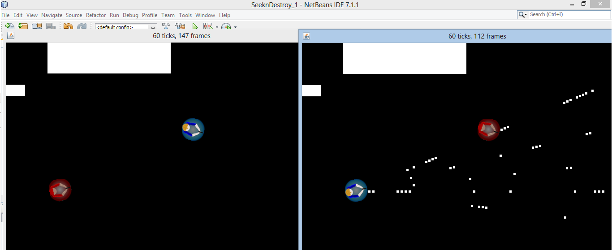

As you can see, we moved the characters to an open area on the map to test functionality. The white blocks in the top left are rudimentary obstacles we decided to use to test bullet impacts. In the game, the current player is blue, while the enemy comes up red. On screen 2, the bottom left play is primary and shooting at the top right player, who just managed to avoid a triple burst of “bullets” coming at him. At this point, we haven’t been able to reproduce bullets on the enemy screen, but we decided to implement it. We plan on sending the bullet origin and direction to the oponent UI, which will take that information, reproduce it, and essentialy “fire” the bullet on its screen. This way we eliminate the clutter of sending constant bullet location updates.